**International Friendship Sailing Experience**

**Event Summary**

We are holding this sailing experience event for the foreign friends who are staying in Japan, on the occasion of gJunior Yacht International Friendship Osaka Regatta 2013h that will take place on the next day, 22nd (Sun) September at Osaka Hokko Yacht Harbor. We hope that the foreign friends living in Japan can also enjoy the sea of Osaka and the sailing on the yacht, even if they have no prior experience in yacht sailing.

The skillful sailors of our Osaka Hokko Dinghy Club members will ride on the rental sailing boats together with the participants and offer the enjoyable sailing experience on the sea.

Also, if any participants are interested in sailing, they are most welcome to join the regatta on the next day, gJunior Yacht International Friendship Osaka Regatta 2013.h You are free to come and observe, too

1. Organizing Authorities Japan Junior Yacht Club Union

Osaka Hokko Dinghy Club

2. Special Sponsor Miki House Company Limited

3. Cooperator Osaka Hokko Universities Yacht Club Union

Yoshimoto Development Company Limited

4. Date September 21st (Saturday)

Event will be carried as scheduled even if small rain

5. Venue Osaka Hokko Yacht Harbor

2-13-18, Tsuneyoshi, Konohana-ku, Oska 554-0052

6. Yacht to be used

　(1) Shikhara Class (Sloop Rig Dinghy Yacht for 1~3 persons)

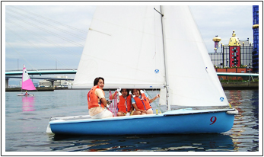

(2) Access Dinghy Class (Dinghy Yacht for 1~2 persons Beginners)

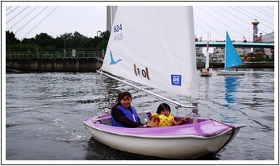

7. Event Schedule Everybody may ride on one or two kinds of Sailing Yacht together with their family and the instructor of the skillful sailor and enjoy the sailing about 1~2 hours.

The 1st Sailing 10:00~12:00 30 persons in total

The 2nd Sailing 13:30~15:30 30 persons in total

All are first-come-first-serve basis

Schedule may be changed on the weather condition.

8. Participants The foreign children and their family who are staying in Japan.

The age limitation will be over 6 years old and under 70 years old for the safety reason.

9. Fee It is free of charge.

However, in case anyone wish to join for gJunior Yacht International Osaka Regatta 2013hon the next day, the entry fee of 4,000 Yen per boat for the children and Friendship Party Fee 1,000 Yen per head for the parents only should be paid at the reception desk on the next day, 22nd.

10. Safety Measures

(1) We will prepare the life jacket for everyone.

(2) Everyone is required to prepare the extra clothes for the change in case of getting wet by the sea water and also to wear the rubber sole shoes.

11. Application and Any Inquiry should be made to Executive Committee of regatta.

Junior Yacht International Friendship Osaka Regatta 2013

Executive Committee

　　　　　　　　　　 Tel: 0466-90-3617, Fax: 0466-90-3618,

Mobile Phone: 090-5993-1298,

E-mail: [info@jjyu.net](mailto:info@jjyu.net)

**Junior Yacht International Friendship Osaka 2013 Executive Committee**

**(E-mail to info@jjyu.net)**

**International Friendship Sailing Experience**

**Application for Participation**

|  |  |  |  |  |  |
| --- | --- | --- | --- | --- | --- |
| Participants | Name | Sex | Age | Nationality | Remarks |
| Leader |  |  |  |  |  |
| Companion 1 |  |  |  |  |  |
| Companion 2 |  |  |  |  |  |
| Companion 3 |  |  |  |  |  |
| Companion 4 |  |  |  |  |  |
| Companion 5 |  |  |  |  |  |
| Address @and etc. of Leader | TEL： Mobile：( ) --  E-Maill： | | | | |
| Hope for time on 21st  Mark **〇** | ・**am** (10:00～12:00)　　　　　　・**pm**(13:30～15:30) | | | | |
| Hope for Participation on 22nd  Mark **〇** | A　Join Regatta Race  a. Access Dinghy Class（single/double Rental boat)  b. Optimist Dinghy Class (By bringing your own boat)  c. Topper Class (Rental boat is available)  (For the entry of b and c, the sailing experience is necessary.)  B　Watch Regatta (am/pm or full day )  C Join Friendship Party  (Number of participants：Children ,Parents ) | | | | |